AAYUSH PATIL - 56

MLDL EXPERIMENT 6

AIM -
Application of K-Means and Hierarchical Clustering on sample datasets

DATASET SOURCE -

https://www.kaggle.com/datasets/shwetabh123/mall-customers

DATASET DESCRIPTION -

The Mall Customer dataset contains information about customers of a shopping mall.

Dataset Size:

  - Total Records: 200 customers
  - Total Features: 5 columns

Features:

- CustomerID – Unique ID for each customer
- Gender – Male/Female
- Age – Age of customer
- Annual Income (k$) – Annual income in thousand dollars
- Spending Score (1-100) – Score assigned by mall based on spending behavior

Features Used in This Experiment:

  - Annual Income (k$)
  - Spending Score (1-10)

Target Variable:

There is no predefined target variable because clustering is an unsupervised learning
technique.
The goal is to group similar customers into clusters based on income and spending behavior.

Dataset Characteristics:

  - Numerical dataset (for selected features)
  - No missing values
  - Suitable for segmentation problems

THEORY -

1. MATHEMATICAL FORMULATION OF THE ALGORITHMS

K-Means Clustering

K-Means divides data into K clusters by minimizing within-cluster variance.

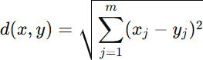
Euclidean Distance

Used to calculate distance between a data point and centroid.

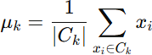
2. Centroid Formula
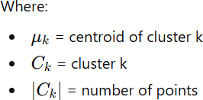

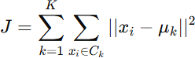
2. Objective Function (WCSS)

Goal: Minimize total squared distance between data points and their respective centroids.

Hierarchical Clustering

Hierarchical clustering merges nearest clusters step by step.

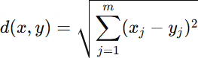
Euclidean Distance

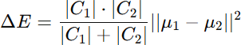
  - Ward Method Formula

3. ALGORITHM LIMITATIONS

K-Means Limitations

  - The value of K must be selected manually.
  - Sensitive to initial centroid selection.
  - Works only for numerical data.
  - Assumes spherical clusters.
  - Sensitive to outliers.

May not perform well when:

    - Clusters have irregular shapes.
    - Data contains extreme outliers.
    - Dataset is highly non-linear

Hierarchical Clustering Limitations

- Computational complexity is high (O(n²)).
- Not suitable for very large datasets.
- Once clusters merge, they cannot be split.
- Sensitive to noise and outliers.

4. METHODOLOGY / WORKFLOW

Step 1: Import Libraries

Imported:

- NumPy
- Pandas
- Matplotlib
- sklearn.cluster
- scipy.cluster.hierarchy

Step 2: Load Dataset
data = pd.read_csv("Mall_Customers.csv") Dataset loaded successfully.

Step 3: Feature Selection

Selected:

- Annual Income
- Spending Score

These features help in understanding customer purchasing behavior.

Step 4: Data Visualization

Plotted scatter plot of income vs spending score to observe distribution.

K-MEANS WORKFLOW

- Calculated WCSS for K = 1 to 10.
- Plotted Elbow graph.
- Observed bend at K = 5.
- Created KMeans model:

kmeans = KMeans(n_clusters=5, random_state=42)

- Fitted model using .fit(X)
- Extracted labels using .labels_
- Extracted centroids using .cluster_centers_
- Plotted clustered data with centroids.

HIERARCHICAL WORKFLOW

- Generated linkage matrix: linked = linkage(X, method='ward')
- Plotted dendrogram.
- Observed natural cut at 5 clusters.
- Created AgglomerativeClustering model: hc = AgglomerativeClustering(n_clusters=5)
- Predicted cluster labels.
- Plotted clustered data.

PERFORMANCE ANALYSIS

Since clustering is unsupervised, accuracy is not used.

K-Means Performance

- Elbow Method indicated optimal K = 5.
- WCSS decreased significantly up to K=5.
- Clusters clearly separated customers into:
  - High income – High spending
  - High income – Low spending
  - Low income – High spending
  - Low income – Low spending
Clusters are compact and visually well-separated.

Hierarchical Clustering Performance

- Dendrogram clearly showed 5 major clusters.
- Ward method produced compact clusters.
- Results visually similar to K-Means.
- Good cluster separation observed.

HYPERPARAMETER TUNING

K-Means

Hyperparameters:

  - n_clusters
  - random_state
  - init
  - max_iter Tuning Done:
    - Tested K from 1 to 10 using Elbow Method.
    - Selected K = 5 based on sharp bend.
    - Used random_state = 42 for reproducibility.

Impact:
Proper selection of K improved cluster quality and separation.

Hierarchical Clustering

Hyperparameters:

- n_clusters
- linkage method Tuning Done:
  - Used Ward linkage.
  - Selected 5 clusters by cutting dendrogram.

Impact:

Ward method minimized variance and produced compact clusters.

Code:

# Step 1: Import Libraries
import tensorflow as tf
from tensorflow.keras import layers, models
import matplotlib.pyplot as plt
import numpy as np
from sklearn.metrics import confusion_matrix, classification_report
import seaborn as sns

# Step 2: Load Dataset
fashion_mnist = tf.keras.datasets.fashion_mnist
(X_train, y_train), (X_test, y_test) = fashion_mnist.load_data()

# Step 3: Normalize Data
X_train = X_train / 255.0
X_test = X_test / 255.0

# Reshape for CNN (add channel)
X_train = X_train.reshape(-1,28,28,1)
X_test = X_test.reshape(-1,28,28,1)

# Step 4: Build CNN Model
model = models.Sequential()

model.add(layers.Conv2D(32, (3,3), activation='relu', input_shape=(28,28,1)))
model.add(layers.MaxPooling2D((2,2)))

model.add(layers.Conv2D(64, (3,3), activation='relu'))
model.add(layers.MaxPooling2D((2,2)))

model.add(layers.Flatten())

model.add(layers.Dense(128, activation='relu'))
model.add(layers.Dense(10, activation='softmax'))

# Step 5: Compile Model
model.compile(optimizer='adam',
loss='sparse_categorical_crossentropy',
metrics=['accuracy'])

# Step 6: Train Model
history = model.fit(X_train, y_train, epochs=10, validation_data=(X_test, y_test))

# Step 7: Evaluate
test_loss, test_acc = model.evaluate(X_test, y_test)
print("Test Accuracy:", test_acc)

# Step 8: Predictions
y_pred = model.predict(X_test)
y_pred_classes = np.argmax(y_pred, axis=1)

# Step 9: Confusion Matrix
cm = confusion_matrix(y_test, y_pred_classes)

plt.figure(figsize=(6,5))
sns.heatmap(cm, annot=True, fmt='d')
plt.title("Confusion Matrix")
plt.show()

# Step 10: Accuracy Graph
plt.plot(history.history['accuracy'], label='Train Accuracy')
plt.plot(history.history['val_accuracy'], label='Val Accuracy')
plt.legend()
plt.title("Accuracy Graph")
plt.show()

# Step 11: Loss Graph
plt.plot(history.history['loss'], label='Train Loss')
plt.plot(history.history['val_loss'], label='Val Loss')
plt.legend()
plt.title("Loss Graph")
plt.show()

# Step 12: Sample Predictions
class_names = ['T-shirt','Trouser','Pullover','Dress','Coat',
'Sandal','Shirt','Sneaker','Bag','Ankle Boot']

plt.figure(figsize=(10,5))

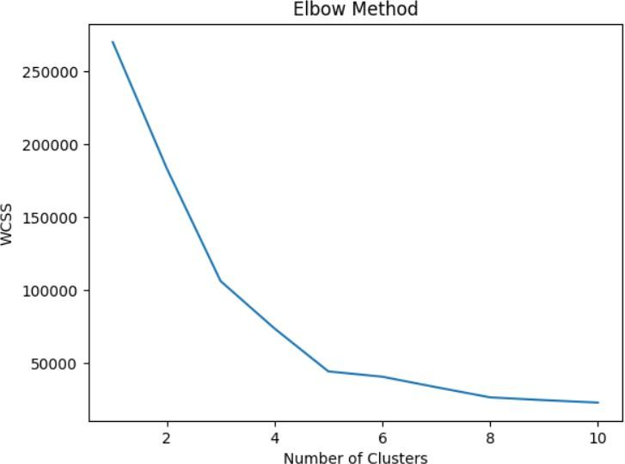
OUTPUT:

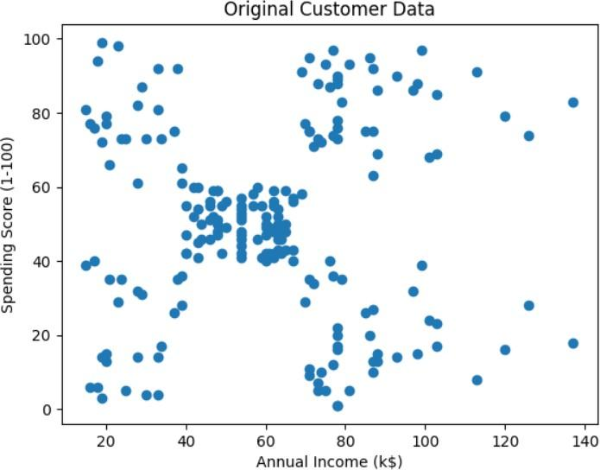
K-Means Clustering:

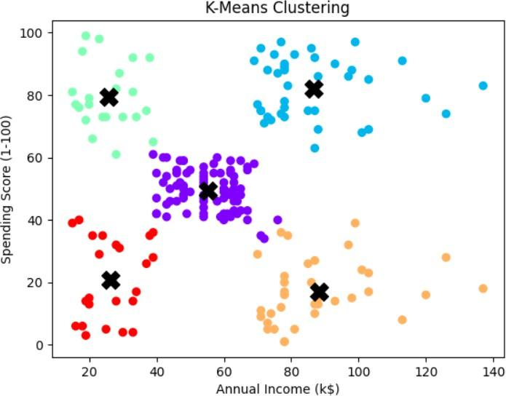
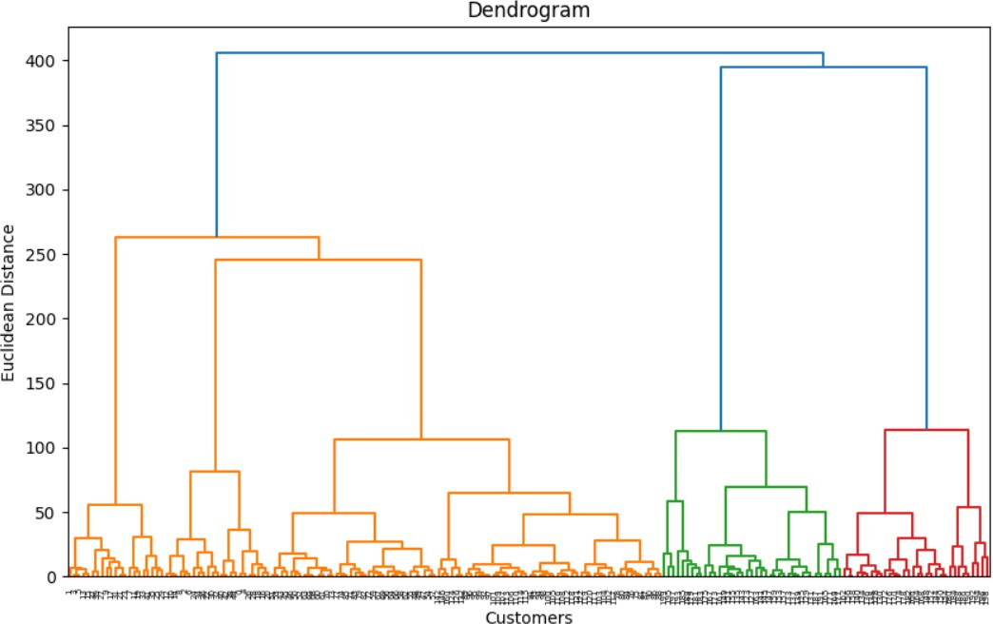
Hierarchical Clustering:

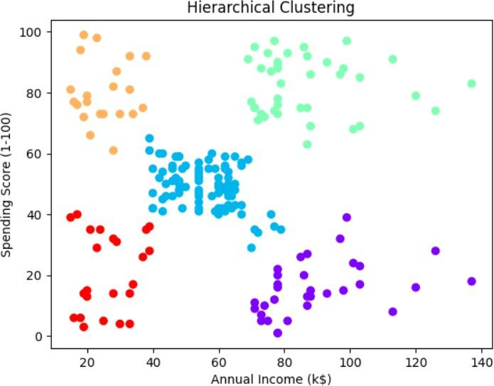
Conclusion:

In this experiment, K-Means and Hierarchical Clustering were applied to the Mall Customers dataset for customer segmentation. Using annual income and spending score, both algorithms successfully divided customers into five meaningful groups. K-Means was faster and easier to implement, while Hierarchical Clustering provided better visualization through dendrogram analysis. The Elbow Method and dendrogram helped in selecting the optimal number of clusters. Overall, clustering techniques proved useful in understanding customer behavior and can help businesses improve marketing strategies and decision making.

